- DDL Commands
CREATE TABLE books (
book_id INT PRIMARY KEY,
title VARCHAR(100),
author VARCHAR(50),
year_published INT
);

INSERT INTO books VALUES
(1, '1984', 'George Orwell', 1949),
(2, 'To Kill a Mockingbird', 'Harper Lee', 1960),
(3, 'The Great Gatsby', 'F. Scott Fitzgerald', 1925);

SELECT * FROM books;
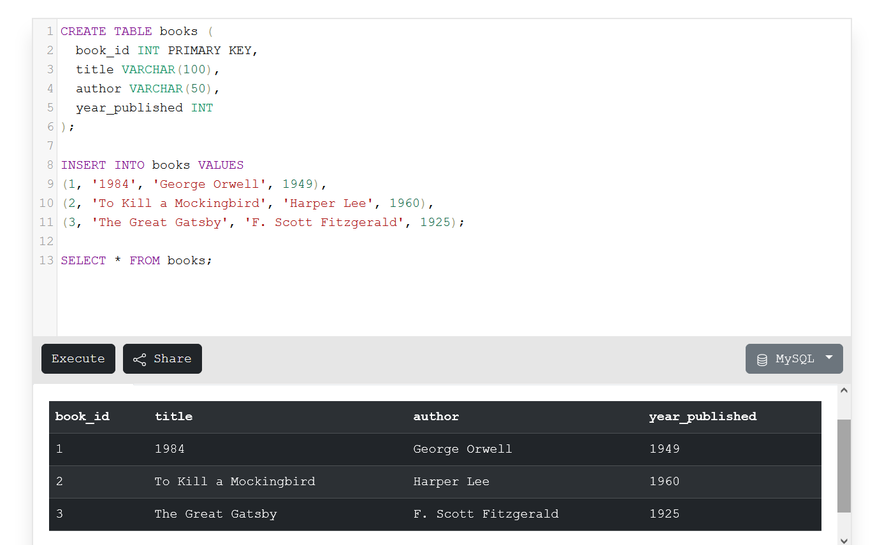

- DML Commands
CREATE TABLE employees (
employee_id INT PRIMARY KEY,
name VARCHAR(50),
age INT,
department VARCHAR(50),
salary DECIMAL(10, 2)
);
INSERT INTO employees (employee_id, name, age, department, salary) VALUES
(1, 'John Doe', 30, 'Sales', 50000),
(2, 'Jane Smith', 28, 'HR', 55000),
(3, 'Alice Johnson', 35, 'Marketing', 60000);
SELECT * FROM employees;
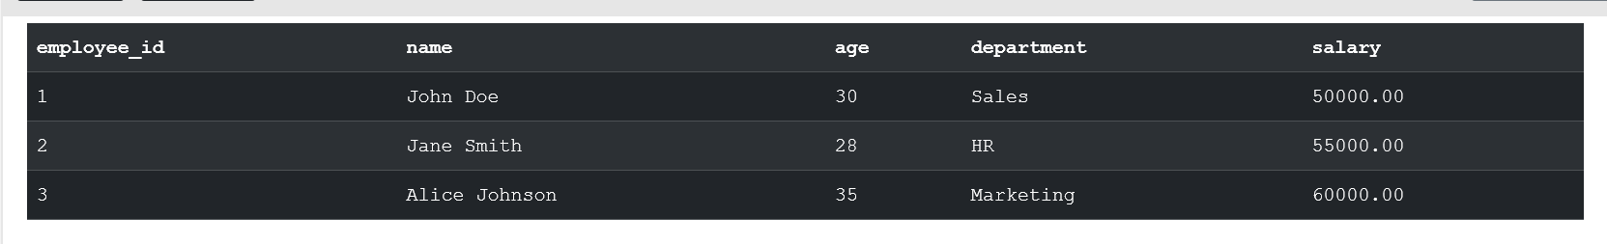
UPDATE employees
SET salary = salary * 1.1
WHERE department = 'Sales';
SELECT * FROM employees;
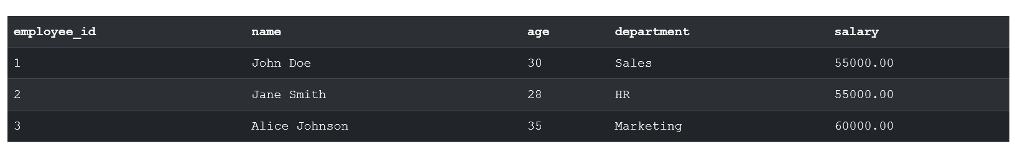
DELETE FROM employees
WHERE employee_id = 3;
SELECT * FROM employees;
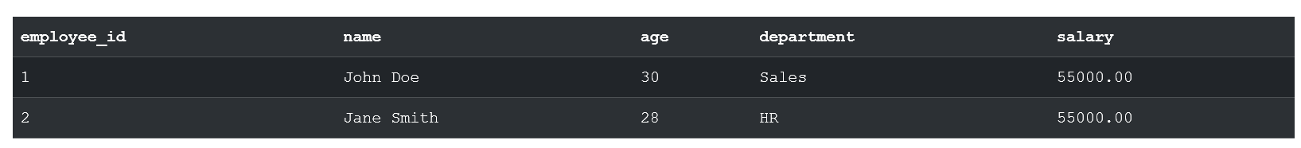
- TCL
CREATE TABLE sales (
sale_id INT PRIMARY KEY,
product VARCHAR(50),
amount DECIMAL(10, 2)
);

INSERT INTO sales VALUES
(1, 'Laptop', 1200.00),
(2, 'Mouse', 25.50);

START TRANSACTION;
INSERT INTO sales VALUES (3, 'Keyboard', 45.00);
ROLLBACK;

SELECT * FROM sales;

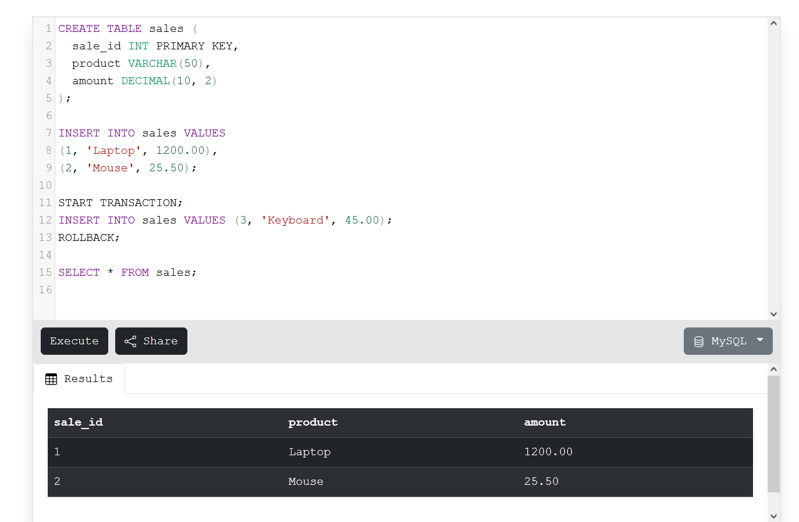
- JOINS
CREATE TABLE employees (
employee_id INT PRIMARY KEY,
name VARCHAR(50),
department_id INT
);

CREATE TABLE departments (
department_id INT PRIMARY KEY,
department_name VARCHAR(50)
);

INSERT INTO employees VALUES
(1, 'Alice', 1),
(2, 'Bob', 2),
(3, 'Charlie', 1),
(4, 'David', 3),
(5, 'Eve', NULL);

INSERT INTO departments VALUES
(1, 'HR'),
(2, 'Engineering'),
(3, 'Marketing'),
(4, 'Finance');

-- INNER JOIN: Returns matching rows from both tables
SELECT e.name AS Employee, d.department_name AS Department
FROM employees e
INNER JOIN departments d ON e.department_id = d.department_id;

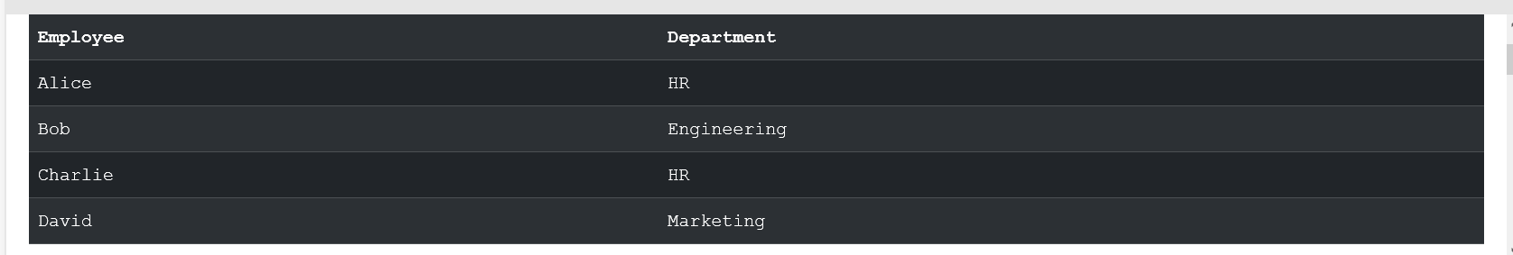

-- LEFT JOIN: Returns all rows from left table and matched from right
SELECT e.name AS Employee, d.department_name AS Department
FROM employees e
LEFT JOIN departments d ON e.department_id = d.department_id;
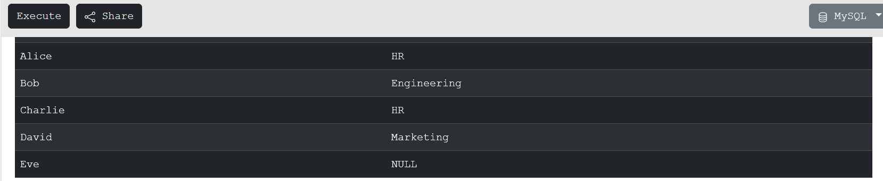

-- RIGHT JOIN: Returns all rows from right table and matched from left
SELECT e.name AS Employee, d.department_name AS Department
FROM employees e
RIGHT JOIN departments d ON e.department_id = d.department_id;
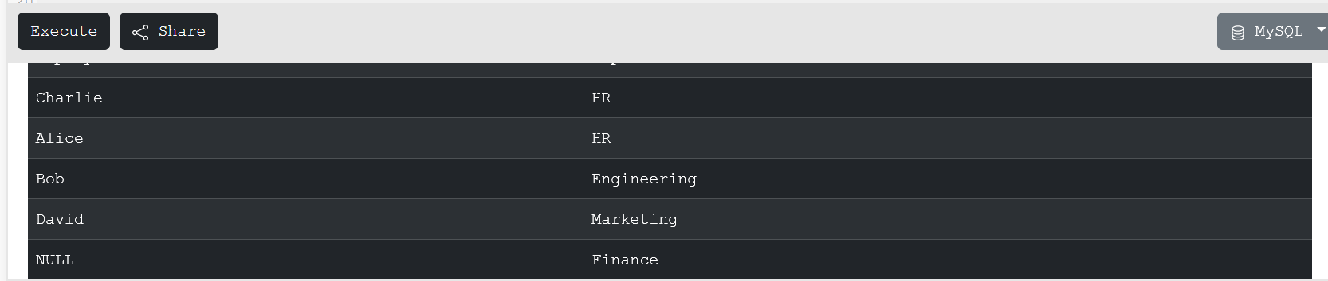

-- FULL OUTER JOIN equivalent: Using UNION of LEFT and RIGHT JOIN (MySQL doesn't support FULL OUTER JOIN directly)
SELECT e.name AS Employee, d.department_name AS Department
FROM employees e
LEFT JOIN departments d ON e.department_id = d.department_id
UNION
SELECT e.name AS Employee, d.department_name AS Department
FROM employees e
RIGHT JOIN departments d ON e.department_id = d.department_id;
